MCT ASSIGNMENT
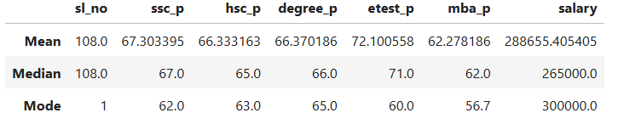
The numerical columns in the dataset are sl_no, ssc_p, hsc_p, degree_p, etest_p, mba_p, and salary. The descriptive statistics help us understand the data.
- Mean (Average):
The sum of all values divided by the total number of observations. For example, the mean of etest_p is 72.10, indicating an average score of 72.10.
- Median (Middle Value):
The middle value when the data is arranged in ascending order. For example, the median of ssc_p is 67, meaning half the observations are at or below 67 and half are at or above 67.
- Mode :
The value that occurs most frequently in the dataset. For example, the mode of salary is ₹3,00,000, indicating that this is the most frequently occurring salary value.

Conclusion:
The descriptive statistical analysis shows that etest_p has the highest mean score (72.10), while mba_p has the lowest mean score (62.28) among the academic performance columns. The mean and median values of most academic columns are relatively close, indicating that their central values are similar. For salary, the mean (₹2,88,655) is higher than the median (₹2,65,000), suggesting that some higher salary values may be influencing the average. Overall, these statistics provide a basic understanding of the dataset and help identify areas for further analysis.

